Project Development Phase
Model Performance Test

Date | 18 February 2026
Team ID | LTVIP2026TMIDS87433
Project Name | Rain Prediction Pipeline Flask
Maximum Marks | 10 Marks

Model Performance Testing:
Project team shall fill the following information in model performance testing template.
S.No. | Parameter | Values | Screenshot
 | Metrics | Classification Model:  Confusion Matrix | 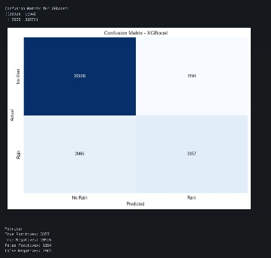
 | Tune the Model | Hyperparameter Tuning  Validation Method | 